

SESSION 1

**Human needs – Human rights   
– Human responsibilities**

**The soup of life**

Human needs cards

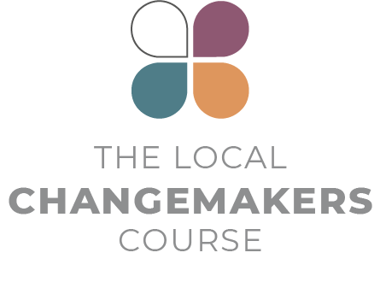

|  |  |
| --- | --- |
| I need…  **freedom.** | I need…  **equality.  No discrimination!** |
| I need…  **to be alive.** | I need…  **freedom  from slavery.** |
| I need…  **safety  from torture.** | I need…  **to have  an identity.** |
| I need…  **the law**  **to treat me  equally and fairly.** | I need…  **protection  when I am  treated wrongly.** |
| I need…  **safety from  arbitrary arrest  and unjust  punishment.** | I need…  **trials to be  fair and public.** |
| I need…  **to be considered  innocent until  proven guilty.** | I need…  **privacy  and dignity.** |
| I need…  **to be allowed  to move around  freely.** | I need…  **to be allowed  to flee from  danger.** |
| I need…  **citizenship**. | I need…  **to be allowed to marry and have  children if I want**. |
| I need…  **the same rights  for men and women  in the family.** | I need…  **to own  my things**. |
| I need…  **to be allowed to**  **think for myself.** | I need…  **to be allowed to have and practice  my religion/beliefs.** |
| I need…  **to be allowed  to change my**  **religion/beliefs if my conscience dictates.** | I need…  **to be allowed to  have opinions  and share them  with others.** |
| I need…  **access to  information.** | I need…  **to meet people,  join and organise  groups.** |
| I need…  **the right  to vote**. | I need…  **a home**. |
| I need…  **health care**. | I need…  **to enjoy  and express  myself**. |
| I need…  **to work  and receive  fair pay.** | I need…  **rest and  relaxation**. |
| I need…  **food**. | I need…  **education**. |
| I need…  **to enjoy the benefits  of science.** | I need…  **a peaceful,  orderly society**. |
| I need…  **to care  for others**. | I need… |
| I need… | I need… |
| I need… | I need… |
| I need… | I need… |