SESSION 1

**Human needs – Human rights   
– Human responsibilities**

**Human Rights Gallery**

Posters







Article 1

We are born free and equal and have our own thoughts and ideas. We should all be treated   
in the same way.

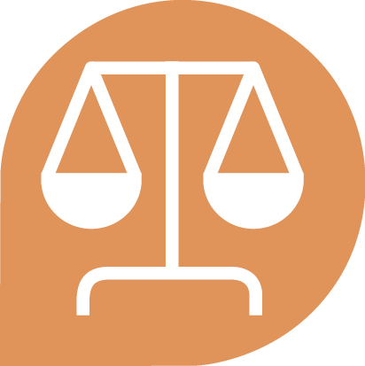

Article 2

These rights belong   
to every human being;   
whether we are rich or poor, whatever country we live in, whatever sex or   
whatever colour we are,   
whatever language we speak, whatever we think   
or believe.



Article 3

We all have   
the right to life   
and to live in   
freedom and safety.



Article 4

Nobody has any right   
to make us a slave   
and we cannot make   
anyone else   
our slave.



Article 5

Nobody has any right   
to hurt or torture us   
or treat us cruelly.



Article 6

We all have the right   
to be recognised   
as a person   
by the law.



Article 7

The law is the same   
for everyone.   
It must treat us all fairly   
and protect us   
from discrimination.



Article 8

The law should   
protect our rights   
and help when someone   
violates our rights.



Article 9

Nobody has the right   
to arrest or put us in prison   
without a good reason,   
or to send us away   
from our country.



Article 10

If someone is accused   
of breaking the law,   
they have the right to   
a fair and public trial.



Article 11

Nobody should be blamed   
for doing something until it   
has been proved that they did it.   
If people say we did   
something bad, we have the   
right to prove that this is not true.   
Nobody should punish us   
for something we did not do,   
or for doing something   
which was not against the law   
when we did it.



Article 12

Nobody should try   
to harm our good name.   
Nobody has the right to   
come into our home,   
open our letters,   
or bother us or our family   
without a very good reason.



Article 13

We all have the right   
to go where we want to   
in our own country   
and to travel abroad   
as we wish.



Article 14

If we are in danger of   
persecution in our own country,   
we all have the right   
to run to safety   
in another country.



Article 15

We all have the right   
to belong to a country   
– to citizenship.

 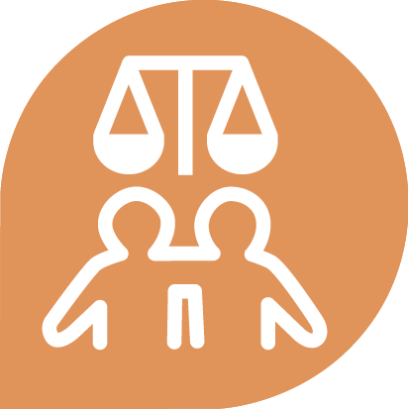

Article 16

Every grown-up has the right   
to marry and have a family   
if they want to.

No one shall be forced to marry.

Men and women have the same rights when they are married,   
and when they are separated.



Article 17

Everyone has the right to   
own things or share them.   
Nobody should take   
our things from us   
without a good reason.

 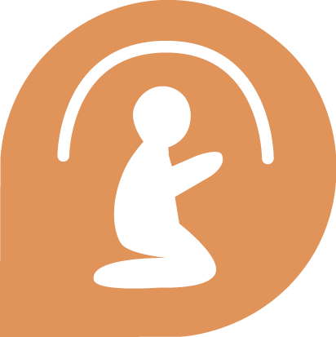 

Article 18

We all have the right to   
think for ourselves and follow   
our conscience, to hold beliefs   
and to have a religion.

We all have the right to practice   
our beliefs alone or with other people, in public and in private.

Everyone has the right   
to change their beliefs and   
religion if they want to.

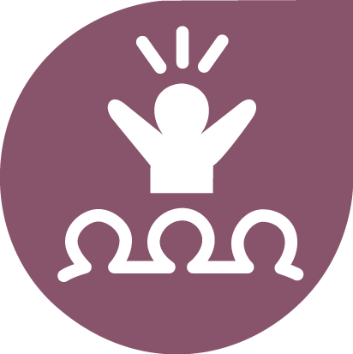 

Article 19

We all have the right   
to access information,   
to make up our own minds   
and to hold, express and share   
our opinions and ideas with   
other people wherever they live,   
through any means we want   
e.g. books or the internet.



Article 20

We all have the right to   
meet our friends and to create groups that do things together, including working together to peacefully defend our rights.

Nobody can make us join   
a group if we don’t want to.



Article 21

We all have the same right   
to stand for election and   
to join the public service.   
Every grown up has the right   
to vote for political leaders   
in regular elections.   
All votes are equal and   
should be made in secret.

**  **

Article 22

We all have the right   
to a home, to have enough   
money to live on and to get   
medical help if we are ill.

We should all be allowed to   
enjoy and express ourselves   
through music, art, craft or sport  
 and to use our skills.

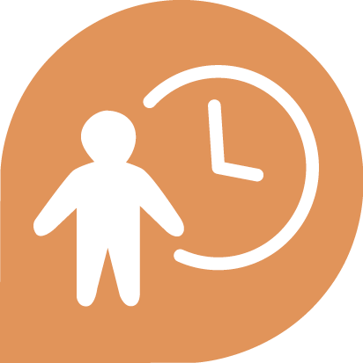

Article 23

Every grown-up   
has the right to a job,   
to get a fair wage for their work,   
and to join a trade union.



Article 24

We all have the right   
to rest from work   
and relax.



Article 25

We all have the right   
to a dignified life,   
with enough food, clothing,   
housing and healthcare.   
Mothers and children,

people without work,

old and disabled people

all have the right to help.



Article 26

We all have the right   
to an education. Primary   
education should be free.   
We should be able to learn

a career, or to make use

of all our skills.



Article 27

We all have the right   
to our own culture, and   
to enjoy the good things that   
science and learning   
bring to society.



Article 28

We have the right to   
live in an orderly, peaceful society and world so that we   
can enjoy our rights   
and freedoms.

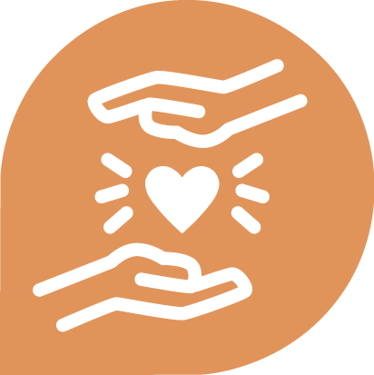

Article 29

We have a duty  
 to other people and   
should protect their rights   
and freedoms.



Article 30

No state or person is   
allowed to act in a way that   
removes rights and freedoms   
from other people.