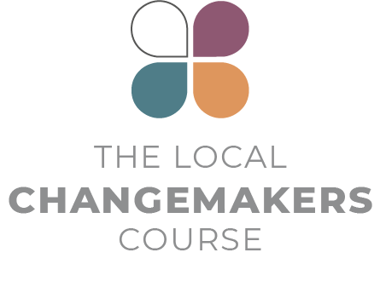SESSION 3

**our many identities**

**Presentation**

**Script**



Presentation Script

Identities and Stereotypes

*This script for the session 3 concluding comments is illustrated by slides 4-13 of the session PowerPoint.*

|  |  |
| --- | --- |
|  | In this session, we have explored how our different identities affect how we see ourselves and others, and how we treat each other. We’ve also thought about the many identities each of us have and how these identities are often shared across religious boundaries. Hindu, Muslim and non-religious women share many of the same disadvantages and challenges in society, as will Buddhists, Christians and Jews who have disabilities, or people of any belief who haven’t got much education. We have commonalities as well as differences. |
|  | Often, religious identities are used to create divides between us. This can result in us looking at people from other communities as if they had a single identity – Jewish, Muslim, Buddhist and so on, and as if everyone with that identity thought, felt and acted the same.  It’s common that people label each other with stereotypes. Often, we consciously or subconsciously assume that people with a particular religious or belief identity are essentially the same, regardless of age, gender, class, nationality or political outlook and regardless of whether they are observant in their beliefs and practice. |
|  | It’s also common that we see other people as being defined by their religion – assuming that everything else about them is determined by that. So, if someone from the group does something wrong, it must be because their religion advocates bad things or is immoral. |
|  | When people from different communities don’t have relationships with each other it’s also easy to assume that the ‘other’ is completely different from ‘us’ – that ‘they’ have different interests, needs, values and feelings than ‘us’. On that basis we might think that they have no insights or wisdom that we could learn from, or even see them as being culturally or morally inferior. |
|  | If instead, we see people who belong to other groups in society as whole people – with multiple identities and life experiences (many of which we share) – then perhaps we can appreciate, empathise and identify with each other in new ways and find ways to cross boundaries and build relationships.  Some identities lead to disadvantages in society, others give us privilege. Recognising our privileges can help us to recognise when we are part of a problem that creates disadvantage for others. And recognising our multiple identities can help us see possibilities and opportunities to stand up against the disadvantage and discrimination that we face and to stand together with others who are facing discrimination. |
|  | **CHANGEMAKER STORY** |
|  | Sameh, a Christian young man, and Hanaa, a Muslim young woman, are from the village of Hijaza in the governorate of Qana in Egypt. They work together to break the barriers between the Muslim and Christian communities in the village.  Hanaa says,  “I saw children who refused to sit or interact together, because they were from different religions.”  Sameh says,  “I felt that it was easier to tackle this together and to try to change their perspectives together. We wanted the children of this area to be the seeds for change.” |
|  | They realised that the children wanted to play football, but the only good space for playing football was in the square outside the Catholic church. The pair approached the local priest, Father Francis, who was very supportive and helped them organise activities.  He says,  “We really need what Sameh and Hanaa are doing in this village and we hope it will spread to all villages.” |
|  | The Muslim children didn’t want to go there at first, but eventually they all followed Hanaa’s lead.  “Slowly but surely, I tried to mix the kids together,” she says.  “Their first reaction was refusal, but step by step, they themselves went on to form new mixed groups.”  Hanaa and Sameh invited the children’s parents to come and watch the group’s activities. The mothers were usually the first to respond positively to seeing the way the children interact together.  Sameh says,  “We need to change, and change begins with faith in an idea,”  and Hanna adds,  “We two are a living example. We work together although we are from different religions. We complete each other and we share one objective. Our objective is the children.” |
|  | **CONCLUSION** |
|  | At the end of the day, we all want the soup of life to be rich and flavoursome! We belong to the same human family and share the same basic needs and rights. When we come together to work for everyone’s rights, we will be much more effective.  In our next two sessions, we are going to learn more about violations of freedom of religion or belief and try to map what these violations look like in our community. Hopefully, that knowledge can help us take the next steps in becoming local changemakers. |

**Source**

Taadudiya, [www.taadudiya.com](http://www.taadudiya.com)   
You can find a YouTube film of Hanaa and Sameh telling their story in Arabic with English subtitles here:What is your story? Egypt.   
Tragically, Hanaa passed away in a traffic accident in 2019.