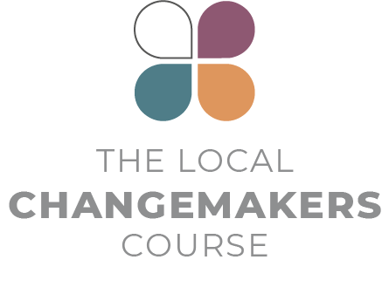SESSION 5

**freedom of religion   
or belief in our COMMUNITY**

**Presentation**

**Script**



Presentation Script

How things get worse (and better)

*This script for the session 5 presentation is illustrated by slides 3-13 of the session PowerPoint.*

|  |  |
| --- | --- |
|  | **INTRODUCTION** |
|  | In the last session:   * + we focused on what violations of freedom of religion or belief look like and how they affect people’s lives,   + we thought about who is committing the violations – the state, through the law and the actions or inaction of officials, or people in the community,   + and we used drama as a tool to begin to explore what these violations can look like and to practice identifying them. |
|  | We’re now going to think about how violations go from being moderate to bad to worse – from occasional incidents affecting individuals to systematic, widespread and severe attacks on peoples’ rights. One way of thinking about how things get worse is to think about three phases - Disinformation, Discrimination and Violence. |
|  | **THREE PHASES OF PERSECUTION** |
|  | The first phase is disinformation. In this phase, prejudices, stereotypes, and lies are spread about individuals or about groups of people – like religious minorities for example. These prejudices are spread in lots of ways – in what parents, teachers and schoolbooks teach children, through the radio or social media or via the speeches of politicians and preaching of religious leaders. |
|  | No society is free from prejudice, but when prejudices and stereotypes go unchallenged, and especially when they are promoted by political and religious leaders, they grow to create a culture of intolerance and give rise to tensions between groups.  When that happens, it becomes easy or even normal for ordinary people, local officials and even the government to start not only thinking and speaking, but also acting in ways that discriminate against others. Disinformation makes discrimination seem acceptable. In its most extreme form, disinformation is used to incite people to believe that not only discrimination but violence is acceptable or even right. |
|  | Discrimination affects people in every area of life. In the last session, we looked at examples of state discrimination – for example discriminatory family and personal identity law, discrimination in the way the law is implemented by the police and the courts and discrimination in the provision of services like education. We also saw examples of discrimination in the private sector affecting people’s access to employment.  No society is free from discrimination, but widespread and systematic discrimination can only persist when it is built upon a culture of ignorance and intolerance. Discrimination wouldn’t keep happening if the majority of people didn’t accept it. |
|  | And just as disinformation creates a foundation for discrimination, together disinformation and discrimination form a foundation for violence. Violence in the community can take lots of forms – from vandalism to harassment to threats to physical violence. And state violence can involve arbitrary imprisonment, torture, and gender-based violence. |
|  | **SCALE, FREQUENCY AND IMPACT** |
|  | All three types of problem – disinformation, discrimination and violence – can take place with different levels of scale and frequency, and with different levels of impact. A violation can affect a few individuals or huge groups. It can be occasional, regular or systematic – which means it is built into the systems and structures of society. And it can have a limited or a devastating impact on the people affected. |
|  | Experience in many countries tells us that the more widespread and severe prejudice and misinformation are, the more widespread and severe discrimination becomes. And the more widespread both of these are, the greater the likelihood of widespread and severe violence. One thing leads to another. This may sound depressing but understanding how things get worse can help us to think about how things could get better. |
|  | **CONCLUSION** |
|  | Everything starts with the way we think, speak about and treat one another. And that is something each one of us can do something about – in our families and personal networks. It is also possible that we could do something about it at the community level – for example in our faith communities, schools and workplaces.  Of course, this isn’t enough. We also need to change the official systems that discriminate and harm people – from bad laws to the behaviour of officials like schoolteachers or police officers. |
|  | To make that kind of change possible we need minorities who know their rights and are equipped to stand up for them, majorities who are prepared to stand with them, and political and religious leaders who understand their responsibilities to respect, protect and promote human rights. |
|  | Making this a reality is a slow and difficult process. That process begins when we analyse our context and identify what the problems are. We can use this three-phase model of disinformation – discrimination – violence to help us do that. |

**Acknowledgement**This script is based on the ‘Three phases of persecution’ model developed by Johan Candelin.